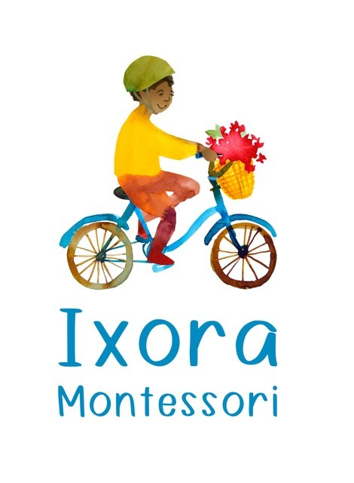

Please note the school’s number (757) 349-2647
Email-info@ixoramontessori.org

Ixora School Calendar is aligned with the other Montessori School in
the area and closed for many of the same Public Holidays as the
James/City/Williamsburg/York County Public Schools.

August 29th Orientation for New Children’s House/Toddler Students 9:00-10:30
September 2nd School Closed for Labor Day
September 3rd School Begins
Phase-In Schedule this week for New CH and Toddler students
Normal school hours for returning students
October 4th School Closed Professional Day
October 17th -Parent Enrichment Night-6:00p.m.
November 4th School Closed Professional Day
November 21-22nd th Parent/Child Visits
November 25-26 School Closed for Parent Teacher Conferences
November 27-29th School Closed for Thanksgiving
December 23rd School Closed Winter Break Begins
January 16th Parent Enrichment Night-6:00p.m.
January 20th School Closed for MLK Day
Jan 26th Open House 1-2pm
Feb 17th School Closed for President’s Day
March 3rd School Closed for Professional Day
April 4th Grandparent’s Day (Noon Dismissal)
April 7-11th School Closed for Spring Break
April 14th School Re-Opens
May 2nd School Closed for Professional Day
May 12-14th Parent/Child Visits (after school)
May 19-20thh School Closed for Parent/Teacher Conferences
May 26th School Closed for Memorial Day
June 66h Noon Dismissal – Last Day of School and Closing Ceremony

July 9-13 School Closed -Summer Preparation

